
INDIVIDUAL | JOINT NOMINEE
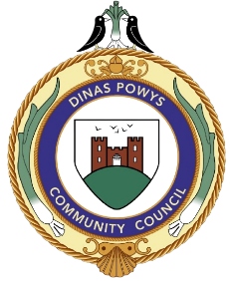
Full Name:

Address:
LOCAL HERO AWARD
NOMINATION FORM

Postcode:
Contact No:

Email
Dinas Powys Community Council would like to recognise extraordinary people who go above and beyond by volunteering their time or talents to helping people and the community.

NOMINATOR
Full Name:

Contact No:

HOW TO NOMINATE A CANDIDATE
- Nominate as many people as you like by completing this form for each person.
- Please check the person you are nominating is happy for you to do so.
- The nominations must be people who live or work in Dinas Powys.
RETURN COMPLETED FORM TO:
Dinas Powys Community Council
Parish Hall
2 Britway Road
Dinas Powys
CF64 4AF

Email: admin@dinaspowys.org
Please put in title Local Hero Award Nomination

Email

Why should we choose your Nominee

Please turn over

